Common mode filter (Output power is measured with filter)

|  |  |  |  |  |
| --- | --- | --- | --- | --- |
| Frequency  (MHz) | Noise power (dBm) | Output power  (no cap) dBm | Output power  (2X100pF) dBm | Output power  (2X2200pF) dBm |
| 12 | -18.50 | -48.6 | -52.7 | -75.2 |
| 36 | -18.50 | -50.3 | -52.1 | -78.1 |
| 60 | -19.5 | -42.8 | -60.6 | -86.4 |
| 84 | -20.3 | -48.3 | -58.1 | -85.2 |
| 108 | -22.6 | -44 | -65.3 | -90.5 |
| 132 | -22.9 | -53.7 | -70.8 | -92.8 |
| 156 | -23.5 | -51.1 | -67.5 | -84.3 |
| 180 | -26.1 | -46.3 | -69.6 | -83.0 |
| 204 | -27.8 | -47.3 | -67.7 | -78.1 |
| 228 | -29.6 |  | -74.0 | -81.2 |

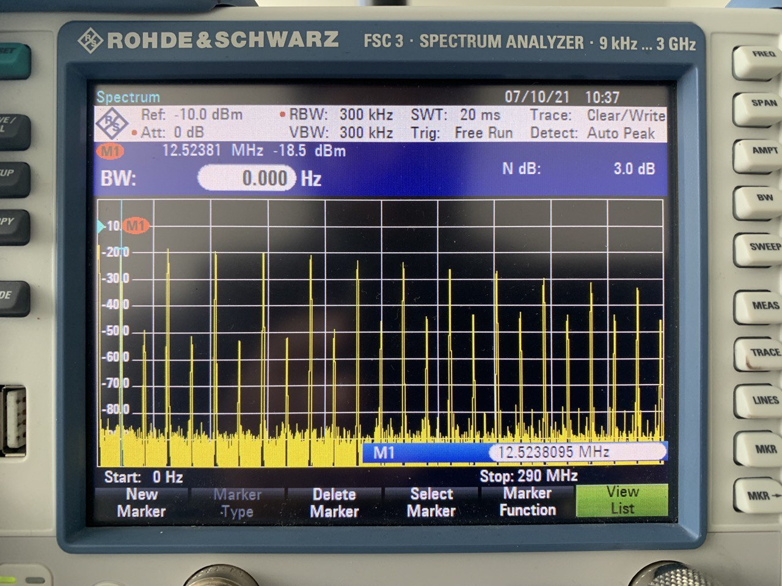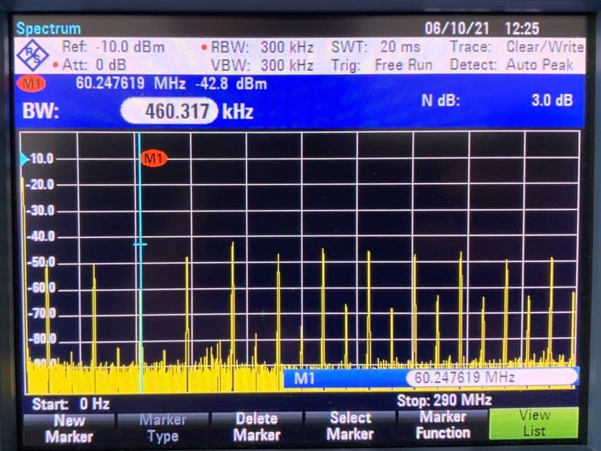

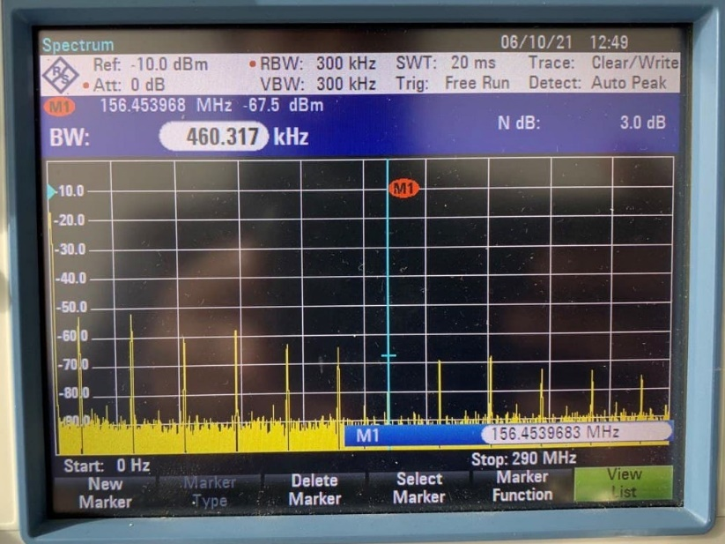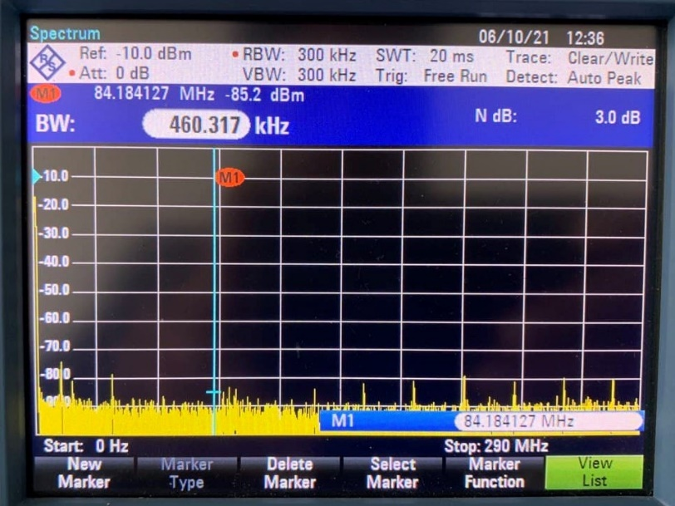

Differential mode filter (Output power is measured with filter)

|  |  |  |  |  |
| --- | --- | --- | --- | --- |
| Frequency  (MHz) | Noise power (dBm) | Output power  (no cap) dBm | Output power  (1X100nF) dBm | Output power  (820pF &470pF) dBm |
| 12 | -18.50 | -24.6 | -49.1 | -29.5 |
| 36 | -18.50 | -35.6 | -51 | -47.6 |
| 60 | -19.5 | -33.8 | -44.9 | -59.6 |
| 84 | -20.3 | -38.6 | -47.3 | -48.1 |
| 108 | -22.6 | -33.7 | -41.3 | -48.2 |
| 132 | -22.9 | -41.1 | -47.9 | -45.2 |
| 156 | -23.5 | -31.3 | -37.3 | -37.9 |
| 180 | -26.1 | -30.4 | -34 | -31.1 |
| 204 | -27.8 | -30.8 | -34.4 | -33.9 |
| 228 | -29.6 |  |  |  |

